

PES UNIVERSITY

100 feet Ring Road, BSK 3rd Stage

Bengaluru 560085

Department of Computer Science and Engineering

B. Tech. CSE - 6th Semester

Jan – May 2022

UE19CS344

DATABASE TECHNOLOGIES (DBT)

Project Report

**Real-Time Twitter IPL Data Streaming and Processing using Spark and Kafka**

PES2UG19CS219: Manjunath Y

PES2UG19CS249: Naveen S Nelogal

PES2UG19CS312: Raghav S K

PES2UG19CS312: Vivek S D

Table of Contents

1. Introduction
2. Installation of Software
3. Input Data
4. Streaming Mode Experiment
5. Batch mode Experiment
6. Comparison of Streaming vs Batch mode Results
7. Conclusion

**Introduction**

The project is focused on streaming of data i.e. tweets from Twitter using the Twitter API and producing the data to a topic on Kafka. The tweets are filtered using the tag “IPL”. The tweets are then streamed and produced to a topic on Kafka. The consumer later consumes the same tweets by subscribing to the topic on Kafka. Spark Streaming is used for the same and the tweets are streamed and then queries are executed on the same using Spark SQL. The data is then stored to MySQL database and batch processing is done on the stored data and SQL queries are performed on the data.

**Installation of Software**

* Installing Kafka

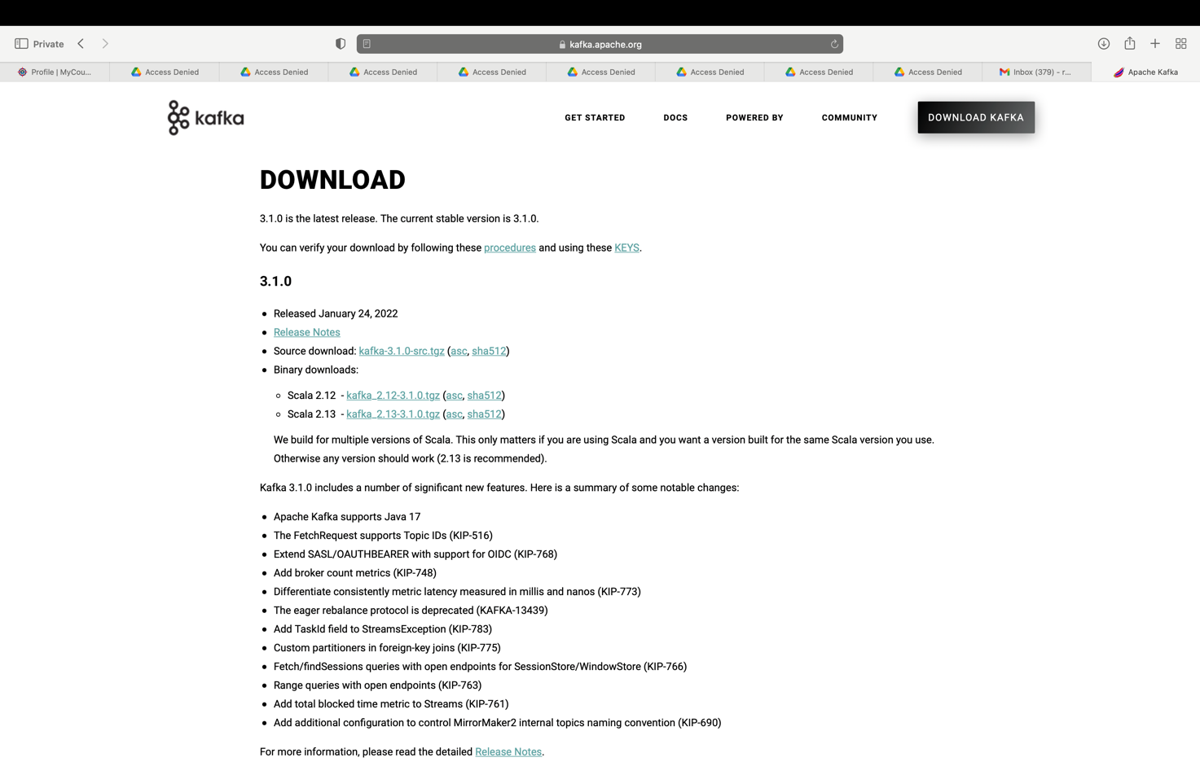

* Installing Spark

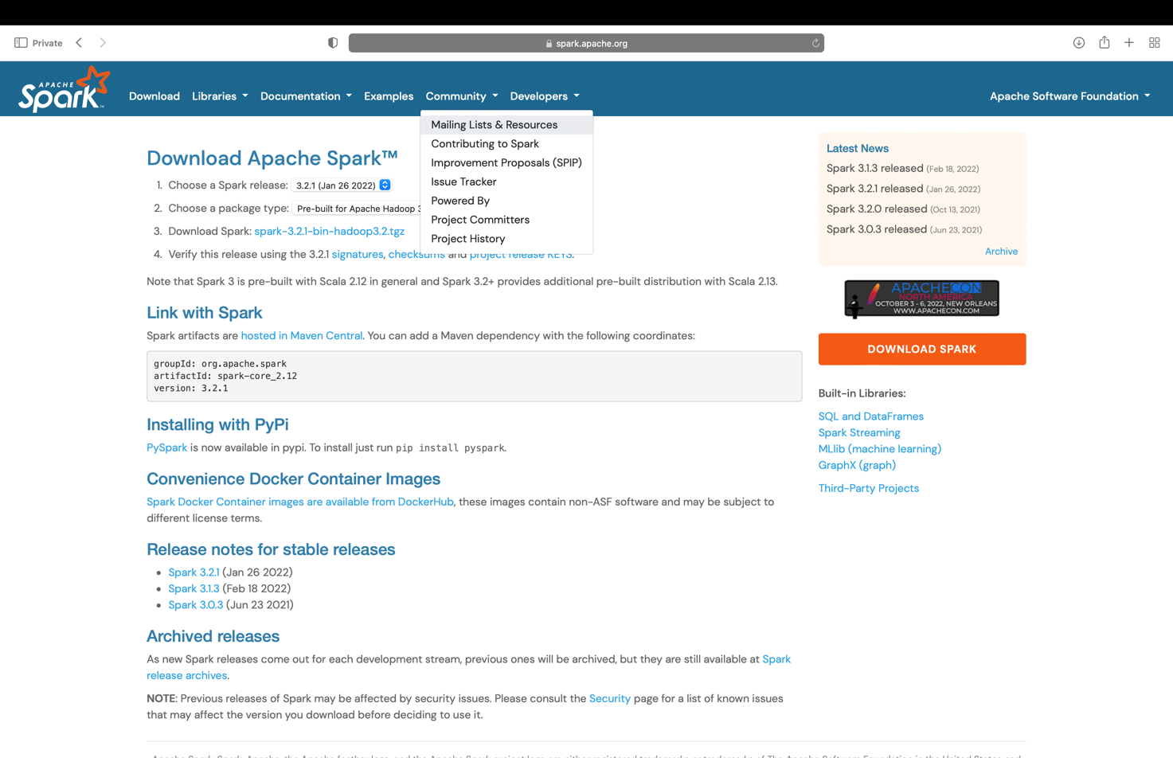

* Installing Python libraries using pip
  + pip install pyspark
  + pip install kafka-python
  + pip install tweepy

**Input Data**

Source of the input data is Realtime data from Twitter API

The twitter API streams data from twitter. The tweets are streamed and the data is in json format. The main field is the text field which consists of the main text the tweet contains and the link to pictures uploaded in the tweet and link to the tweet.

Twitter data is considered big data due to the sheer volume, velocity and the variety of the data.

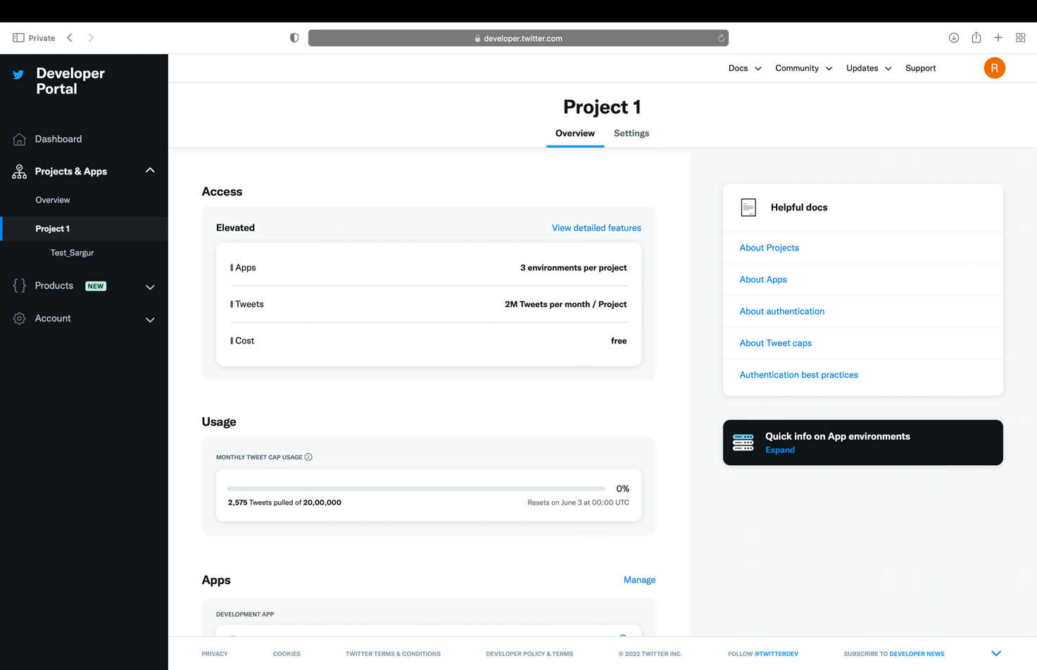

**Streaming Mode Experiment**

Starting ZooKeeper

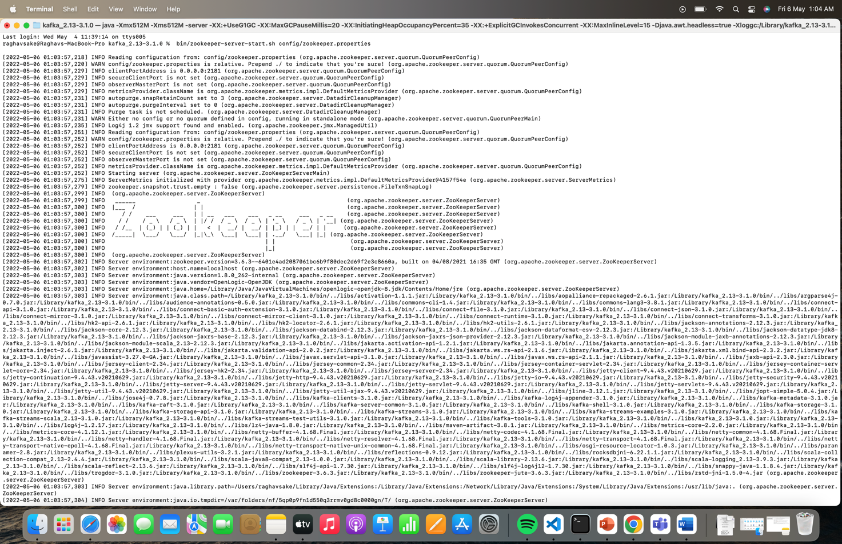

Starting Kafka Server

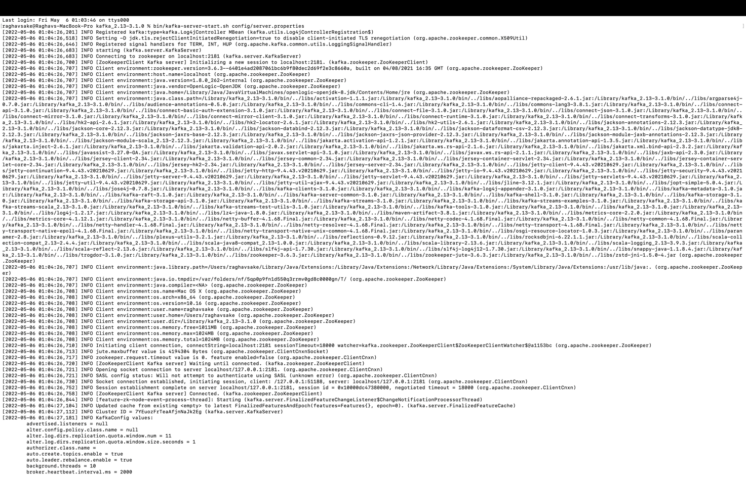

Creating a Kafka Topic

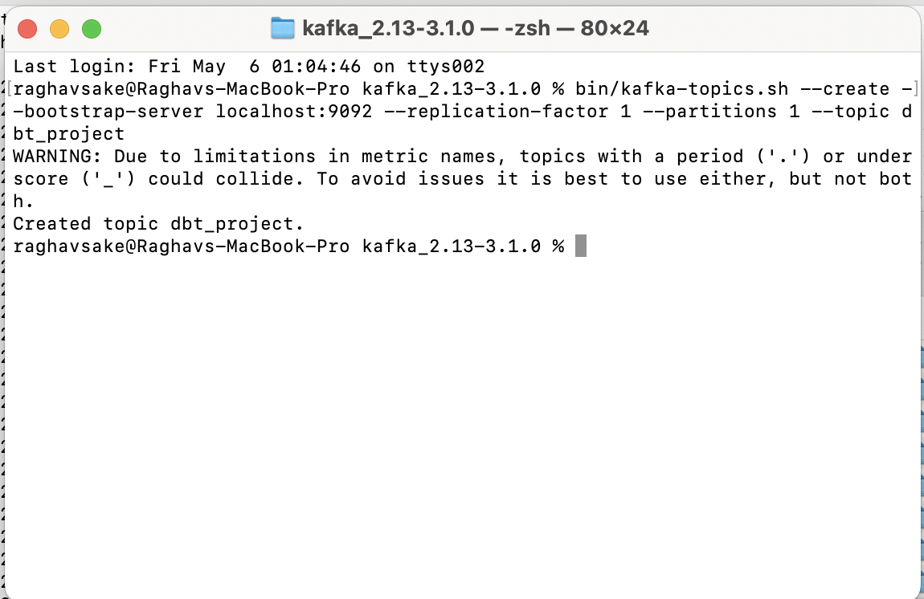

Streaming data into kafka topic

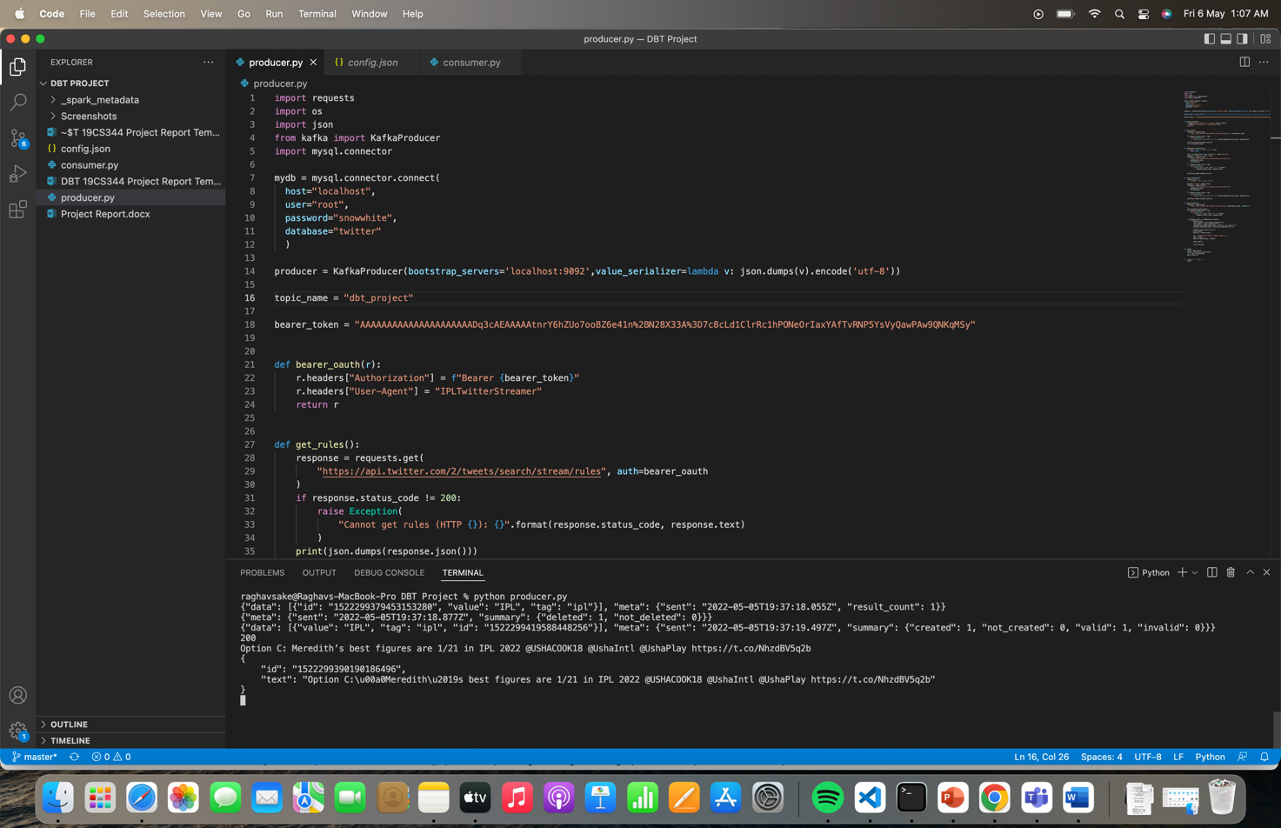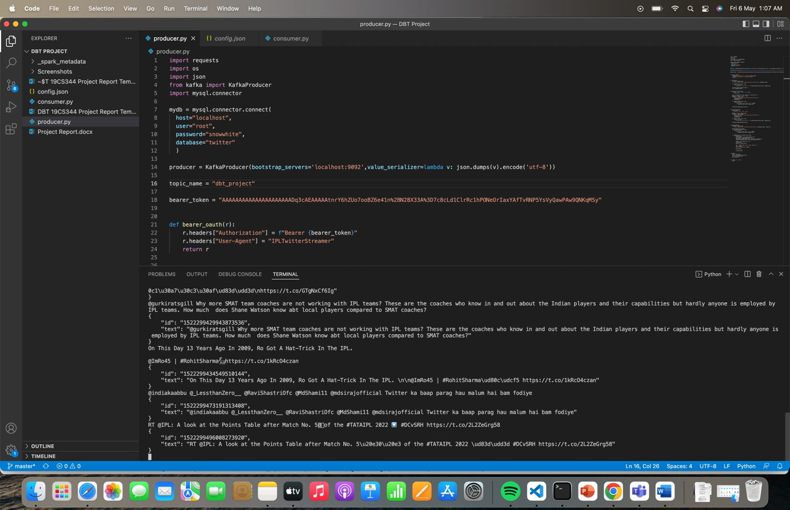

Subscribing to Kafka Topic and Streaming

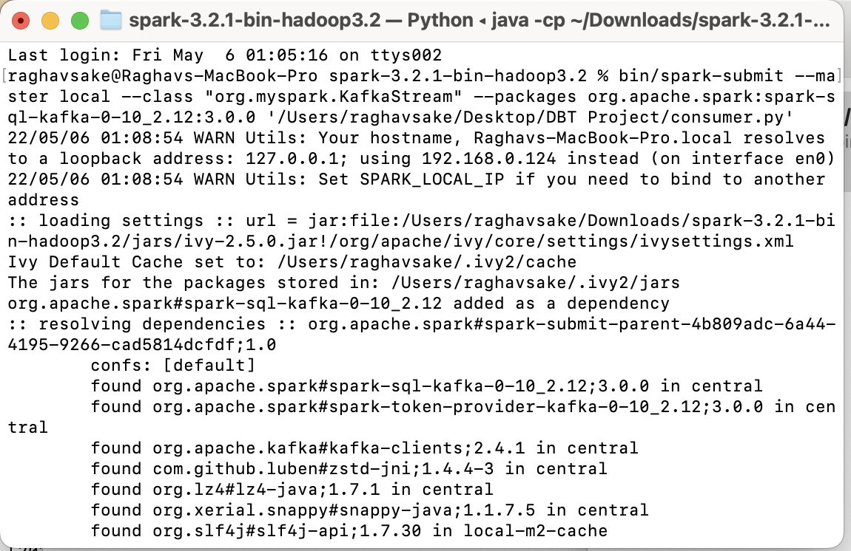

The text in tweets streamed and the count of number of tweets

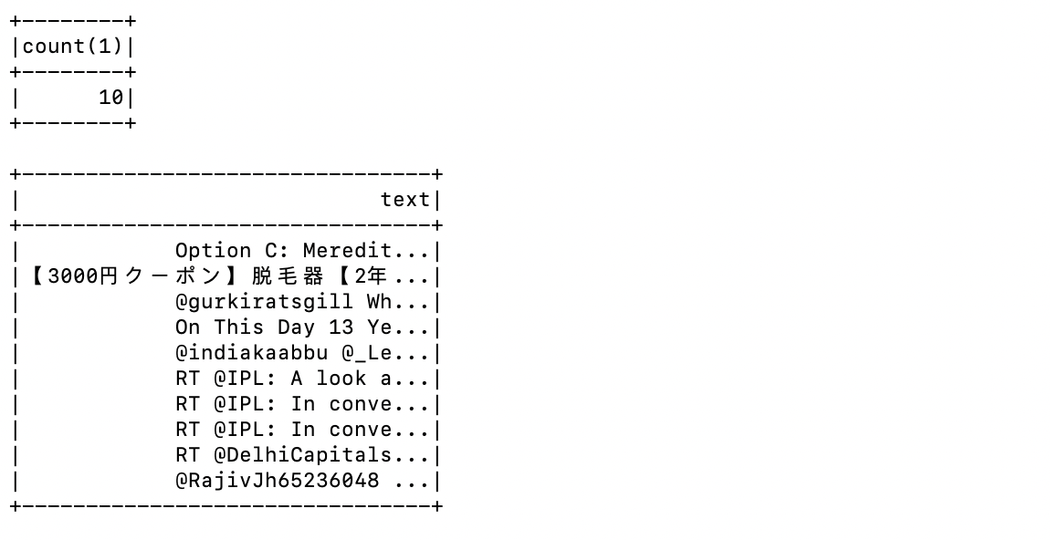

The words split and stored from all tweets and the count

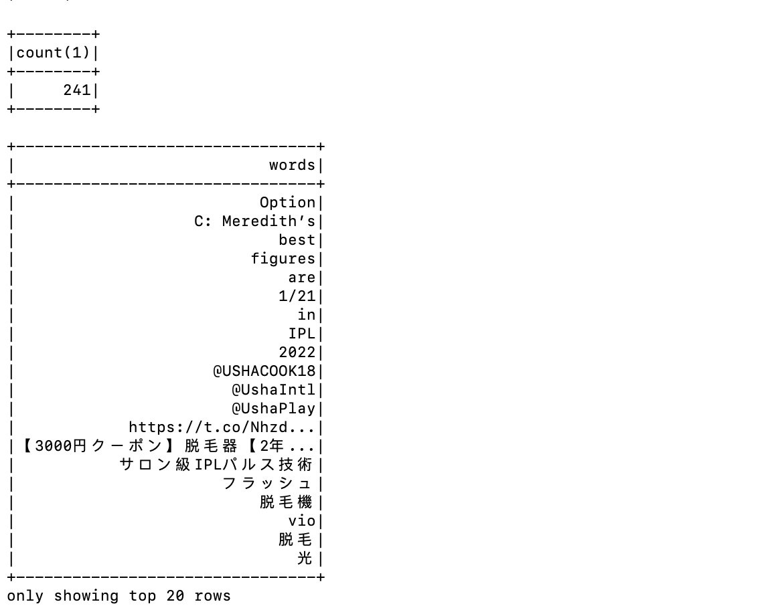

Query1 - The number of RTs which is basically the number of RTs

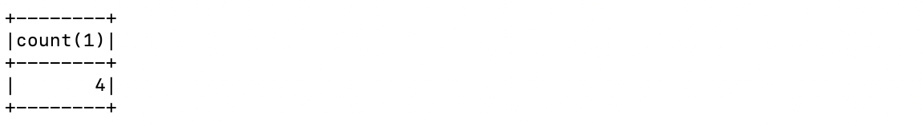

Query2 – The number of tweets containing the word “T20”

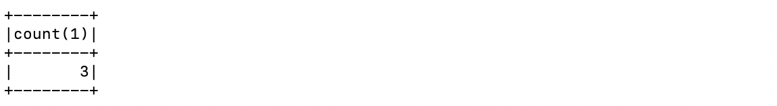

**Batch Mode Experiment**

The tweets streamed are also stored in the MySQL database and we try to query the database for the same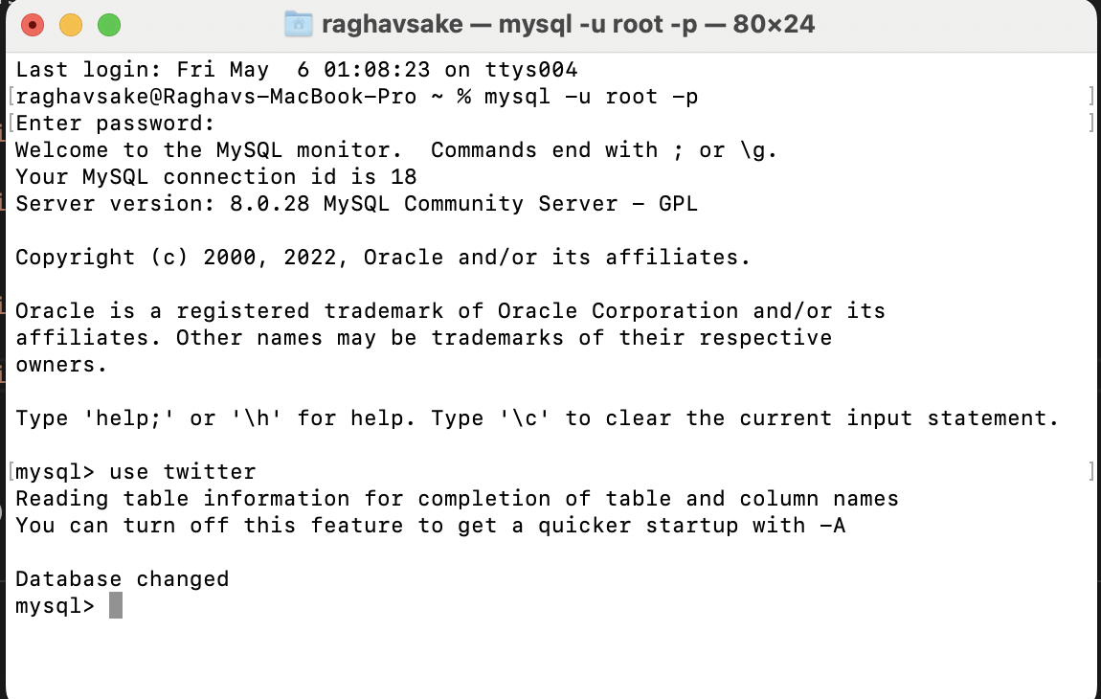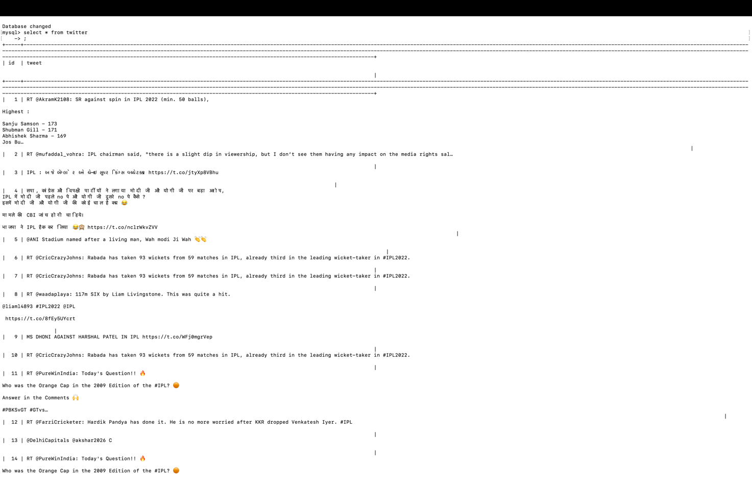

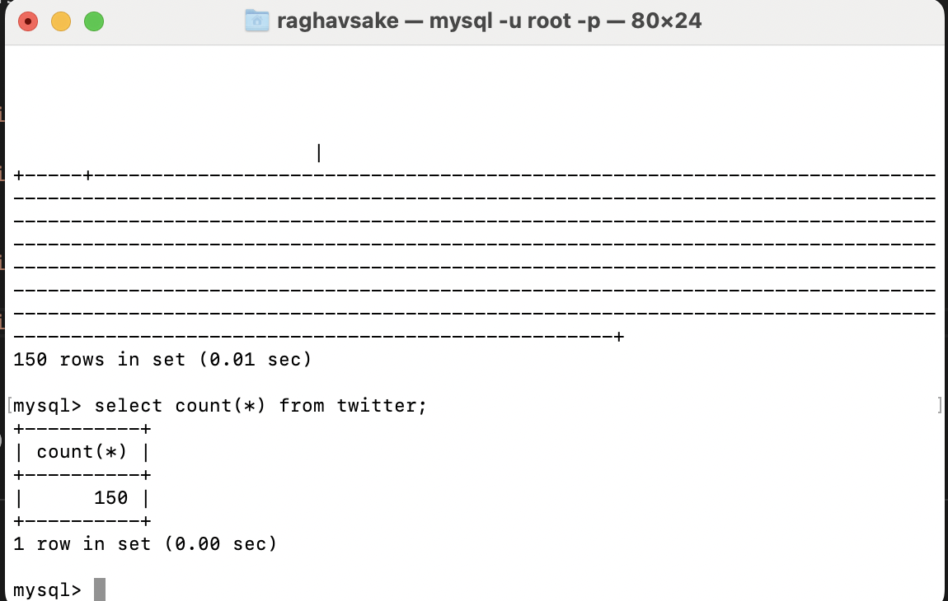

Query1 - The number of RTs which is basically the number of RTs

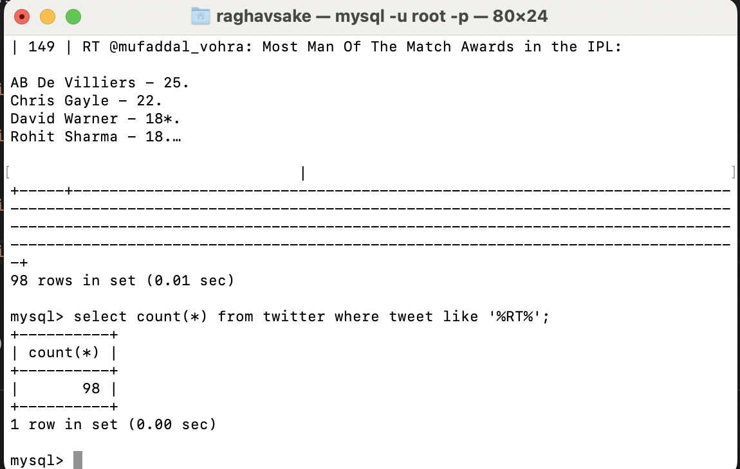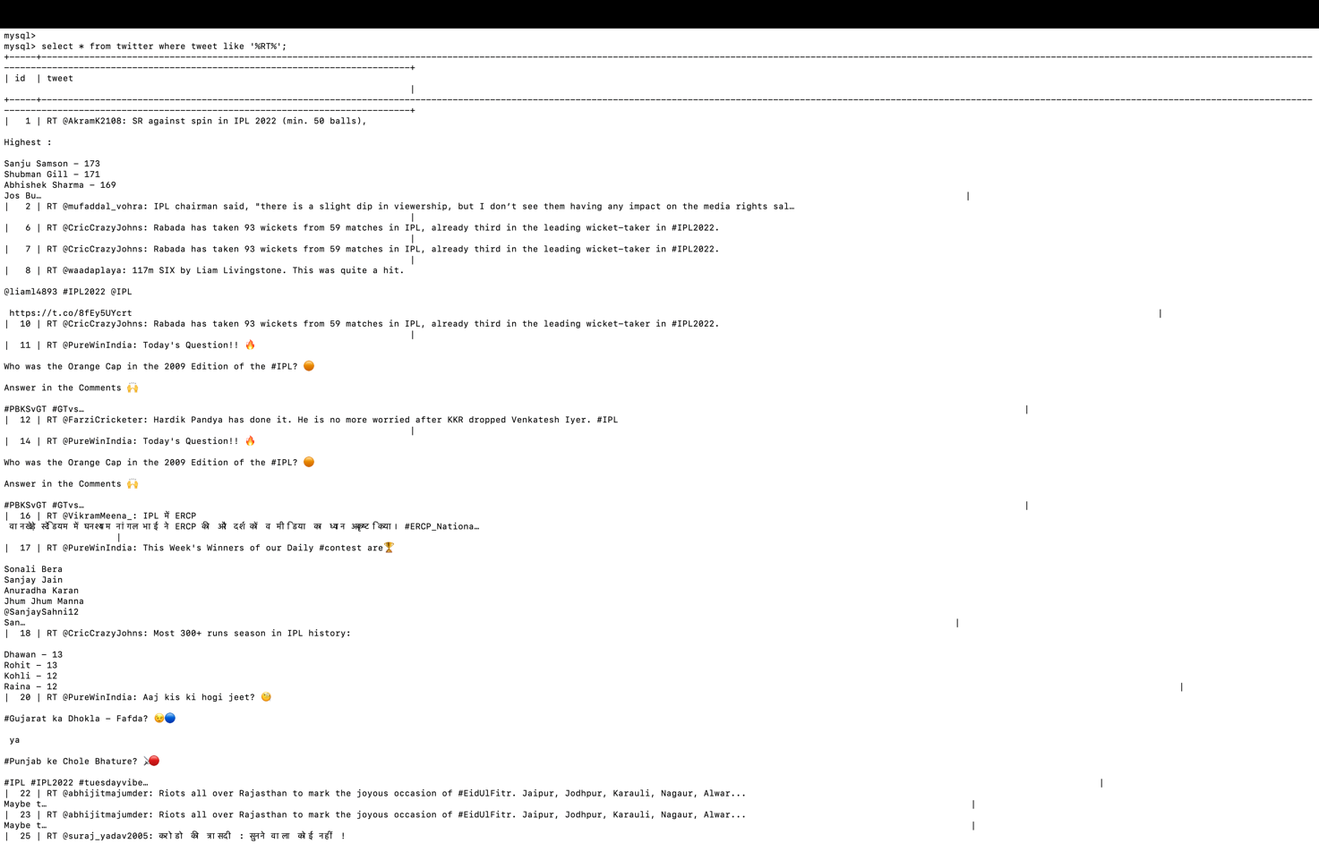

Query2 – The number of tweets containing the word “T20”

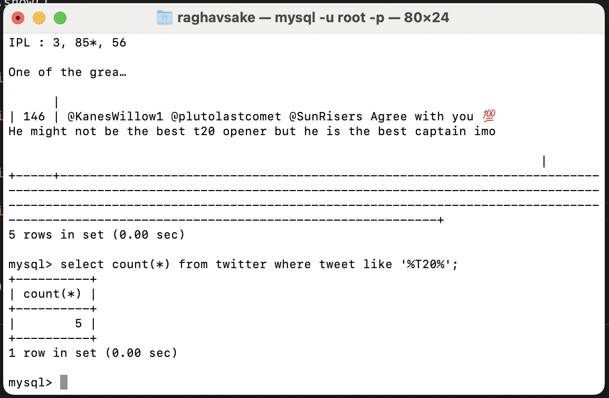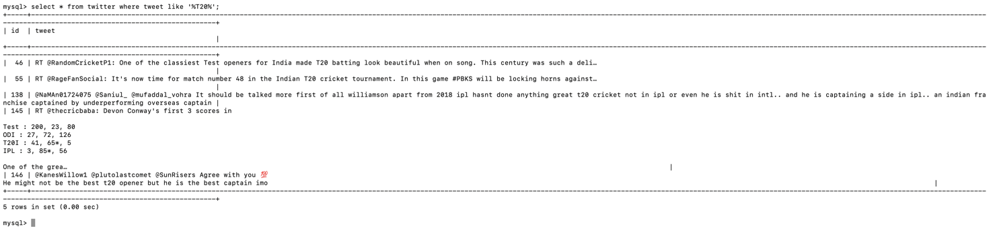

**Comparison of Batch Mode Experiment vs Streaming Mode Experiment**

The comparison of batch mode vs streaming mode for the following scenarios

* Query has to be done once on the twitter dataset

In this scenario the result of batch mode turns out to be much more efficient and faster. Since data is processed at once we save a lot of RAM memory and also is faster as the entire batch is processed at once. In Stream processing each part of the window is processed and stored and with the velocity of the data produced by the producer it makes it slower.

* Time for which data is produced – 15 minutes
* Time taken by Stream Processing Queries – 1 minute
* Time taken by Batch Processing Queries – 28 seconds
* Repeated Querying on the dataset

In this scenario the result of the stream mode turns out to be much efficient and faster. The same data has to be queried and thus makes batch processing slower. The intermediate results are stored in stream processing and thus makes it faster

* + Time for which data is produced – 15 minutes
  + Time taken by Stream Processing Queries – 1 minute per query
  + Time taken by Batch Processing Queries – 2 minutes per query + time taken to store

**Conclusion**

Thus we can conclude that batch processing is useful when a single query has to be executed on entire batch at once and stream processing is better when queries are executed repeatedly on different sizes of data.